**Tribometer** - Work Instruction

The following is a synthesis of the manuals and documentation provided by the manufacturer “TA Instruments”. Processes are amended to fit the laboratory environment at Tecnológico de Monterrey Campus Estado de México.

**History of changes:**

13Mar2019 - 1st version of the document

**Edited by:**

Antonio Osamu Katagiri Tanaka <A01212611@itesm.mx>

**Revised by:**

Nora Argelia Tafoya Medina <nuorriael@itesm.mx>

Dora Iliana Medina Medina <dora.medina@tec.mx>

Table of Contents

Startup Procedure 3

Shutdown Procedure 4

Install a Geometry 5

Install the Lower Stage 6

Remove the Lower Stage 8

# Start-up Procedure

1. **Ensure** that the air supply is turned on.  
     
   **Open** the **black** ball/T valve and then the **orange** ball/T valve.  
   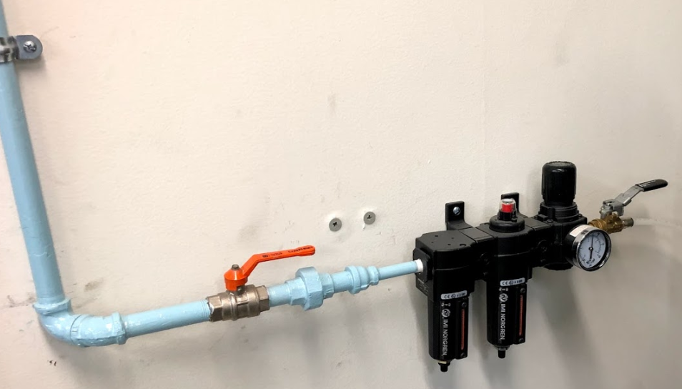  
   The valves in the figure above are in their open position  
     
   **Ensure** the gauge meter reads 30 (±2) psi-+  
   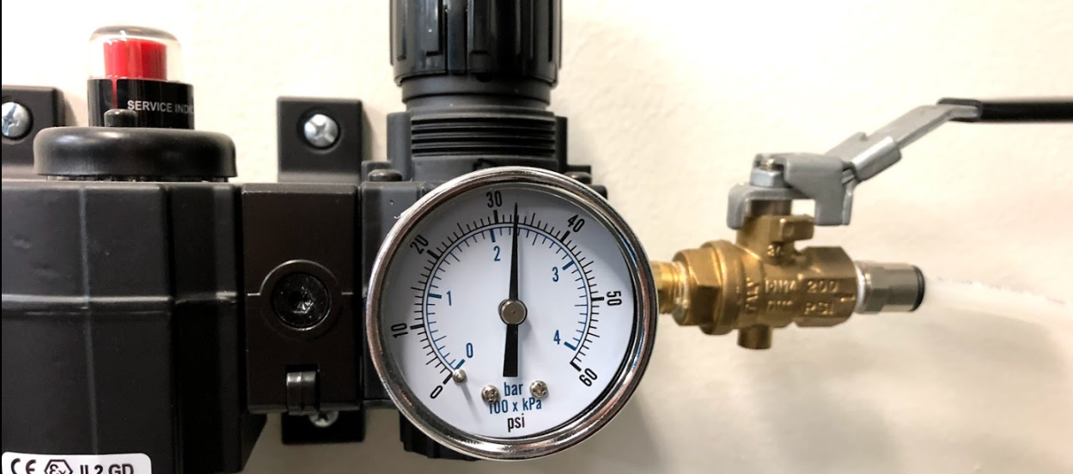  
     
   **Plug** the instruments to the orange (isolated ground) outlet  
   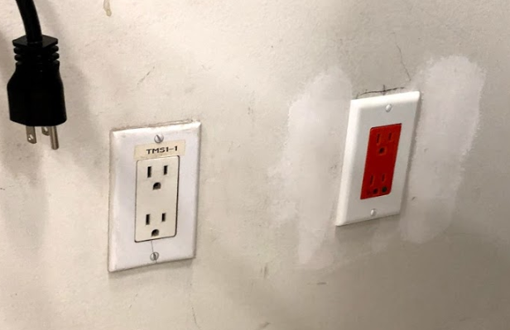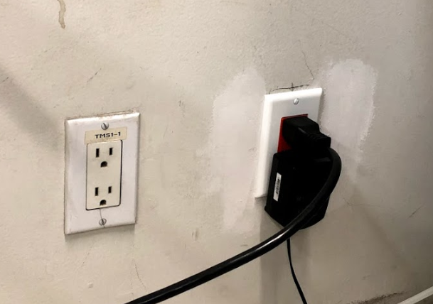
2. **Turn** on fluid circulation.  
     
   The TA-supplied Air Cooled Circulator is located below the working table, next to the isolated ground outlet  
   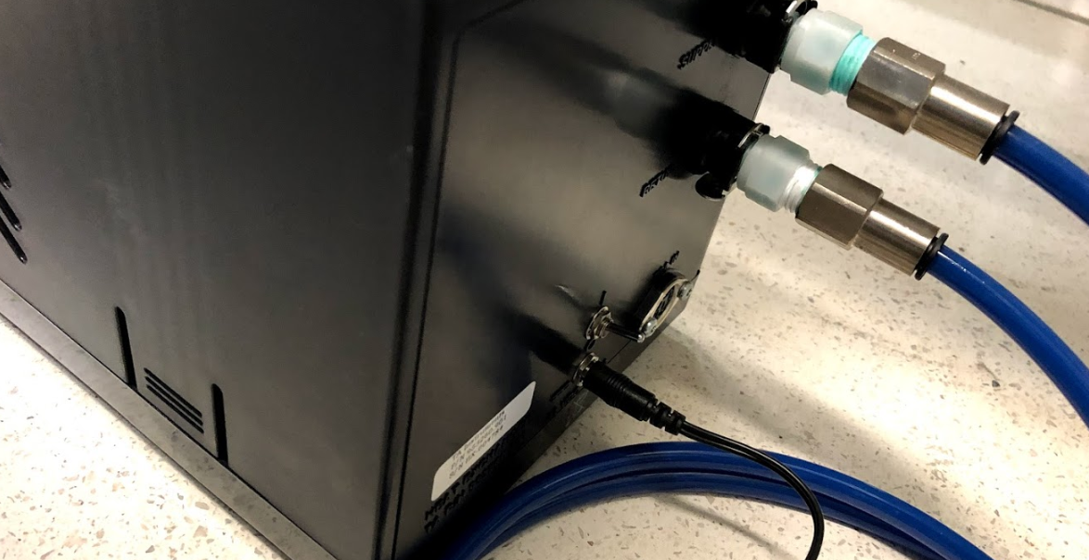  
   The switch in the DOWN position indicates the fluid circulation is OFF; similarly,  
   the switch in the UP position indicates the fluid circulation is ON.

ON/OFF switch

(in its ON position)

1. **Remove** (if fitted) the bearing clamp by holding the clamp and turning the draw rod counter clockwise  
     
   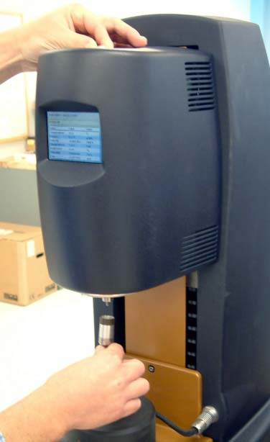  
   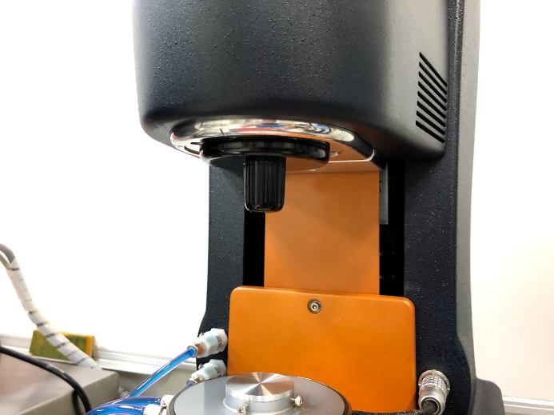  
     
   **Place** the bearing clamp at the back of the instrument’s body.  
   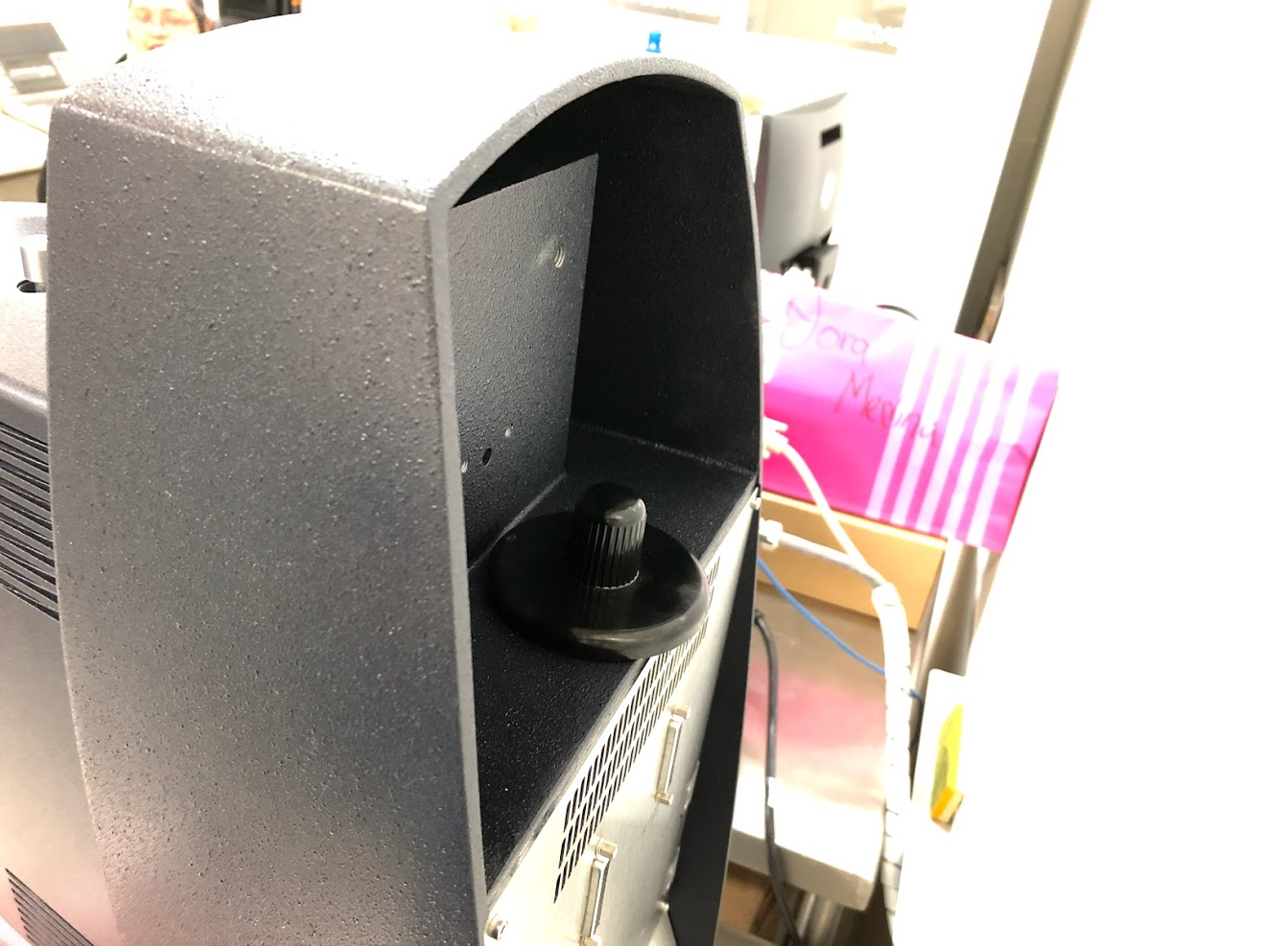

Draw rod

Bearing clamp

1. **Power** on the system by pressing the power switch on the Electronics Control Module (AKA. Electronics Box) to the On “I” position.  
     
   The following figure illustrates the Electronics Control Module  
   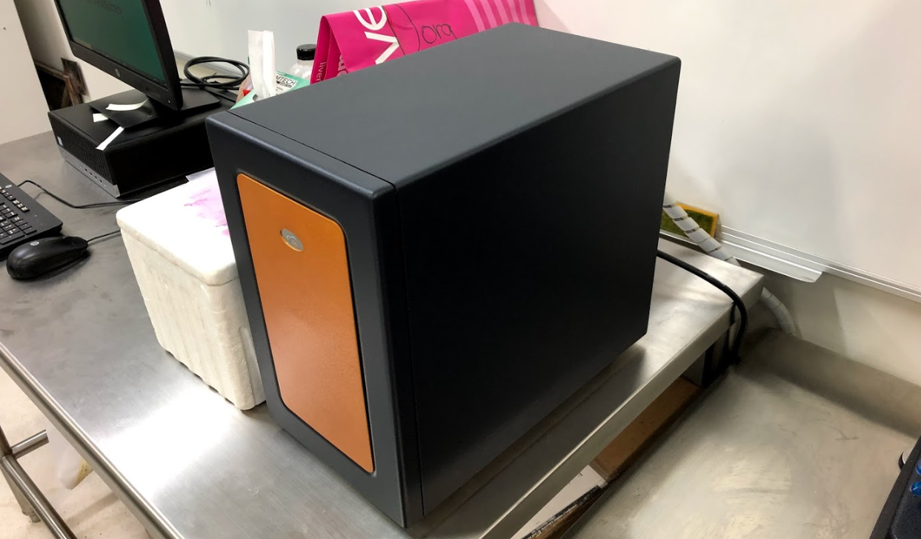  
     
   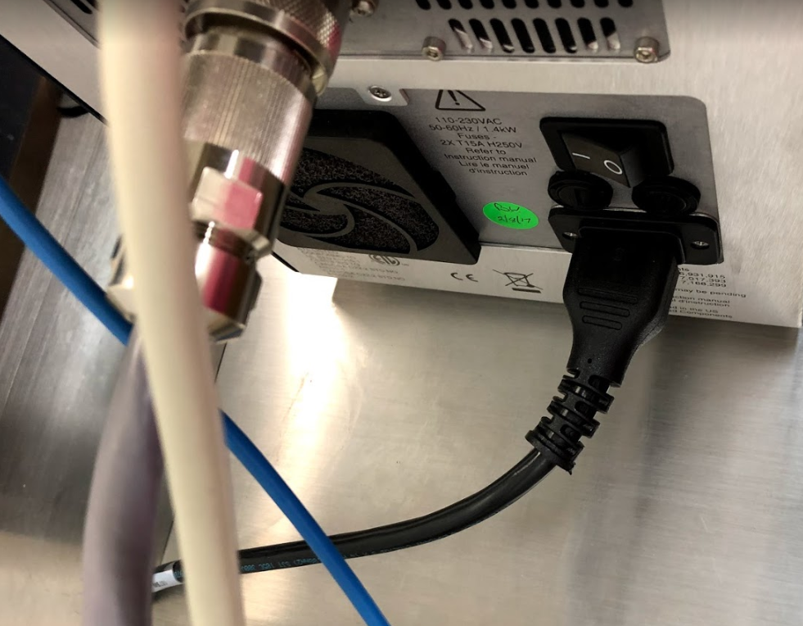

ON/OFF switch

(in its ON position)

1. **Connect** the instrument to the software.  
     
   **Turn** on the working station PC.  
   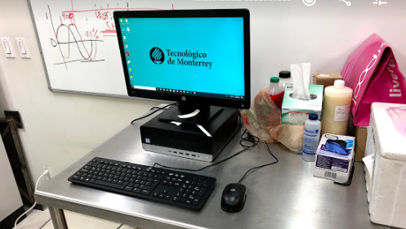  
     
   **Open** the TA instruments (TRIOS) software, by clicking on the desktop shortcut.  
   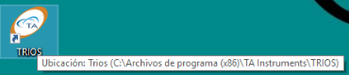  
     
   **Ensure** the TA software recognizes the instrument and **connect** to it.  
   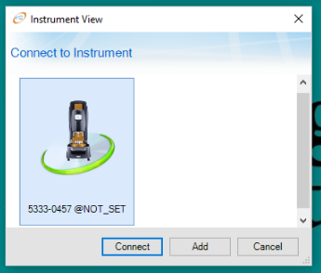

Click on “Connect” to conclude the start-up process

# Shutdown Procedure

1. **Exit** the TA instruments (TRIOS) software.
2. **Turn** off the power to the instrument by pressing the power switch on the Electronics Box (AKA. Electronics Control Module) to the Off “0” position.  
     
   The following figure illustrates the Electronics Control Module  
     
     
   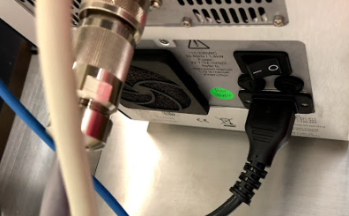

ON/OFF switch

(in its OFF position)

1. **Turn** off any fluid circulation.  
   The TA-supplied Air Cooled Circulator is located below the working table, next to the isolated ground outlet  
   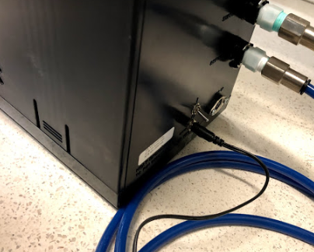  
   The switch in the DOWN position indicates the fluid circulation is OFF; similarly,  
   the switch in the UP position indicates the fluid circulation is ON.

ON/OFF switch

(in its OFF position)

1. **Fit** the bearing clamp.

**Push** the bearing clamp up the spindle and hold.  
**Rotate** the draw rod clockwise  
  
normally, the bearing clamp will be placed behind the instrument’s body.  
  
  
  
The draw rod shall pull the geometry up into position. (tight but not forced)

Draw rod

Spindle

Bearing clamp

1. **Turn** off the air supply.  
     
   **Close** the **orange** ball/T valve and then the **black** ball/T valve.  
     
   The valves in the figure above are in their open position

# Install a Geometry

1. **Ensure** the compress air supply is turned on.
2. **Ensure** the instrument is powered on and initialized.
3. **Remove** the bearing clamp by holding the clamp and turning the draw rod counter clockwise
4. **Push** the geometry up the spindle and hold.
5. **Rotate** the draw rod clockwise  
     
     
     
   The draw rod shall pull the geometry up into position. (tight but not forced)

Draw rod

Spindle

Geometry

# Install the Lower Stage

The following sections explain how to **attach** temperature modules using “Smart Swap”. The **installation** procedure is typically the same for all modules.

TIP: Make use of disposable gloves and tissue paper as some liquid may stain.  
The lower stage attachments are stored in black containers/boxes.

1. **Press** the “release button” on the control panel, as described in the figures below.  
     
   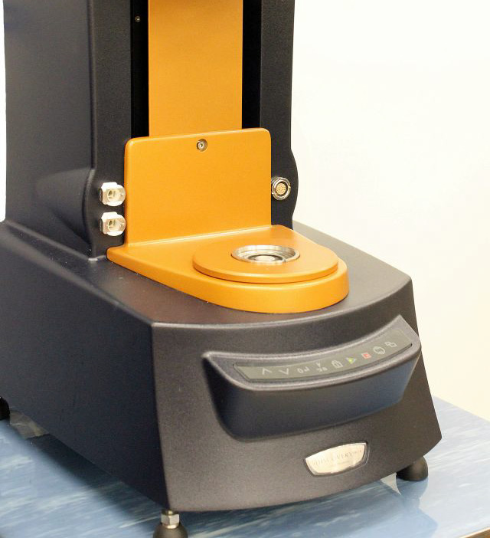  
     
   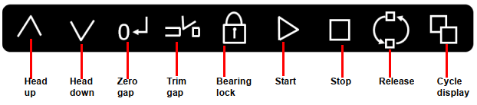  
     
   A continuous green light indicates that the attachment can be fitted.  
   **Notice** that the release state will only stay active for 10 seconds after the “release button” is pressed.

Release button

1. **Fit** the attachment as shown below.  
     
   **Ensure** the mark and slot are align.  
   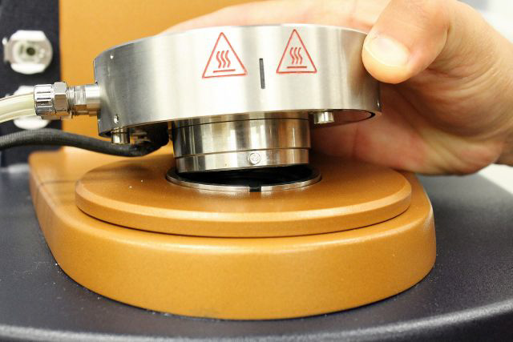  
   The installation shall fit as follows:  
   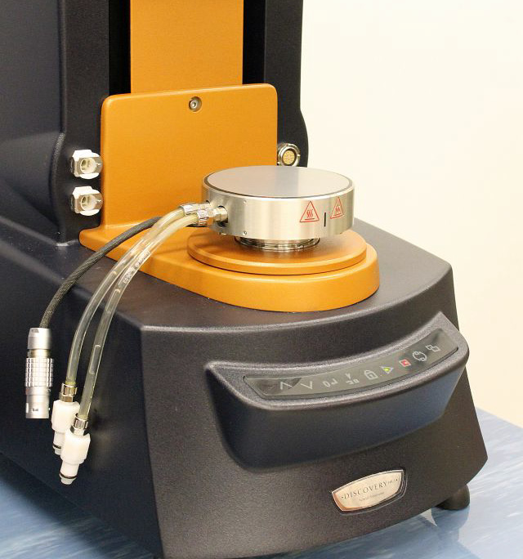

Mark

Slot

1. Connect the power cable and the fluid hoses.  
   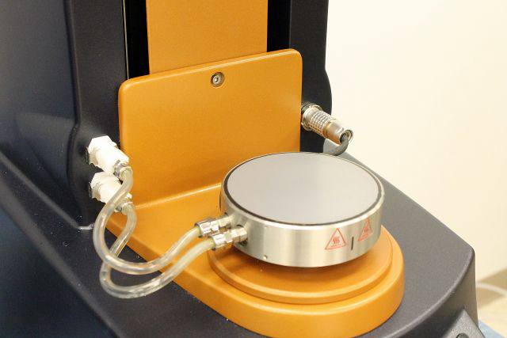

Power cable

Fluid hoses

# Remove the Lower Stage

The following sections explain how to **detach** temperature modules using “Smart Swap”. The **removal** procedure is typically the same for all modules.

TIP: Make use of disposable gloves and tissue paper as some liquid may stain

1. **Press** the “release button” on the control panel, as described in the figures below.  
     
     
     
   

Release button

1. **Disconnect** the power cable and the fluid hoses.  
   

Power cable

Fluid hoses

1. **Press** the “release button” again in the front panel.  
     
     
   **Notice** that the release state will only stay active for 10 seconds.
2. **Remove** the attachment from the instrument.
3. **Store** the removed attachment in its black container/box.